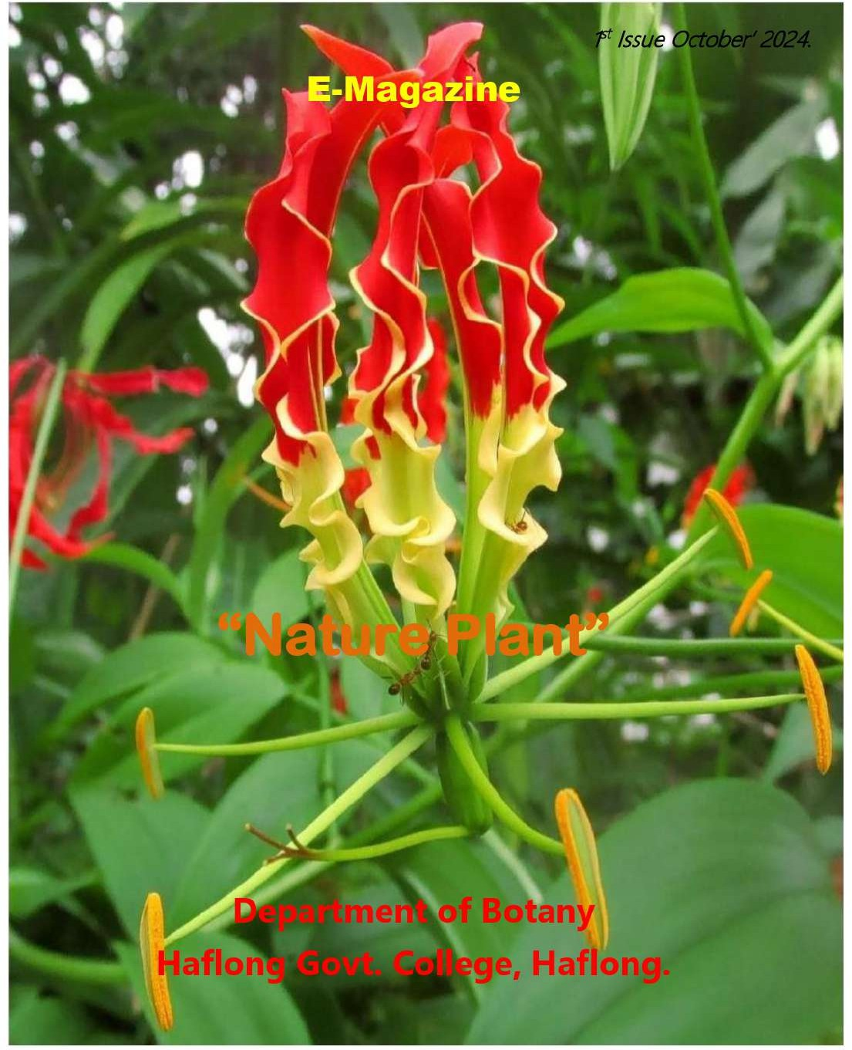



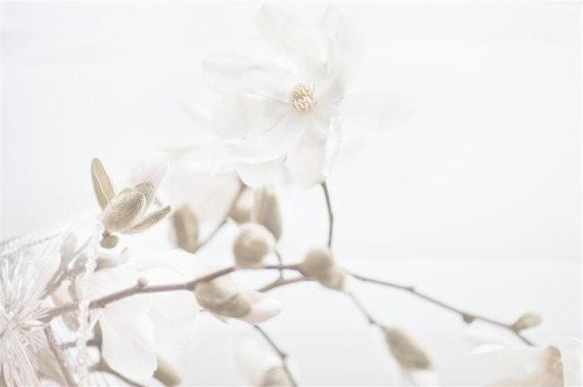
NATURE PLANT
An annually published E-Magazine
By The Department of Botany
Haflong Govt. College, Haflong
-788819.
Volume no 01||Issue no 01



Haflong Govt. College
Affiliated to the Assam University
Batch 2024-2025

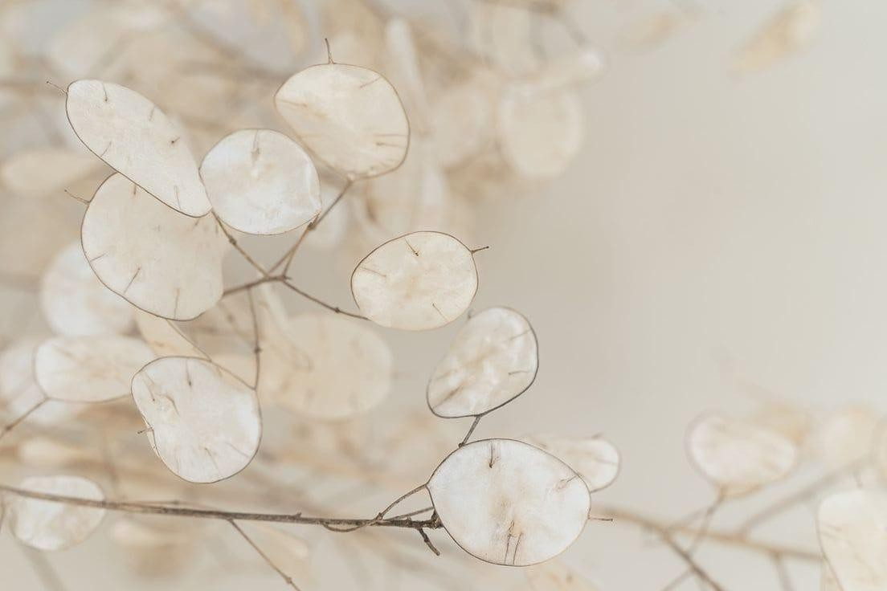
Contents
- From the Principal’s Desk
- Message from the Head of the Department, Botany
- Message from the editorial board
- Introducing the faculty members Department of Botany, Haflong Govt. College
- Introducing the Editorial Board
- Departmental Activities
- Co-curricular Activities

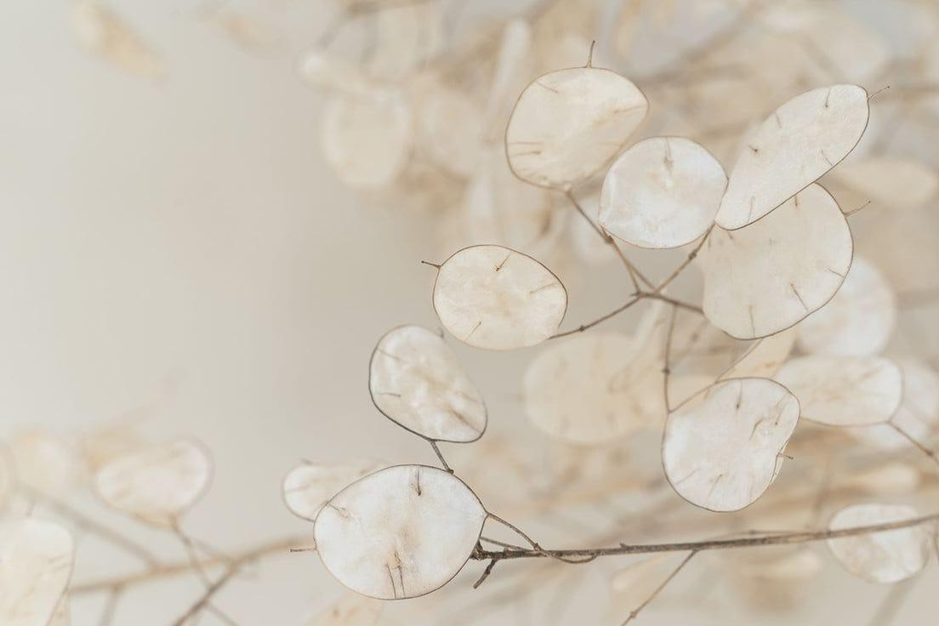
Contents
- Seminar Topics
  - Flora of Western and Eastern Himalayas. (Samjona Lama)
  - Tea Processing. (Nikita Hojai)
    - Phytoremediation. (Nirmali Kemprai)
    - Endemic Species of Indian Flora. (Felica Lalhrietzing)
      - Fatty Acids and it’s Importance.(Babitha Naiding)
      - Uses of some common essential oils.(Hemsringdao Khersa)

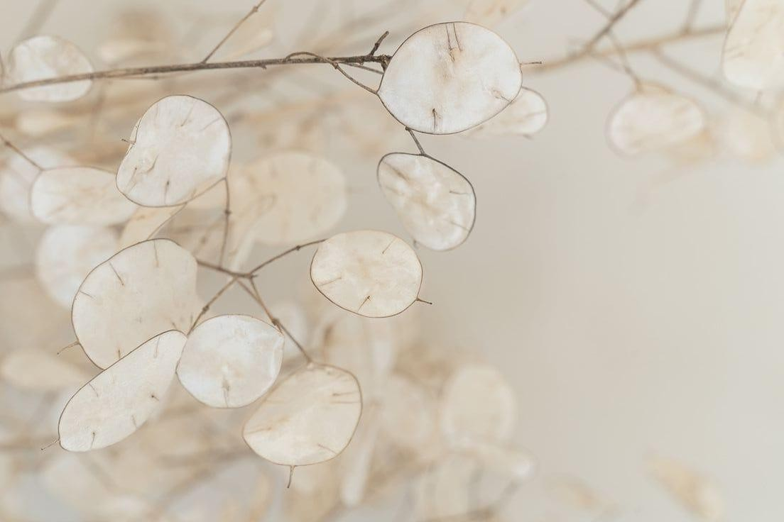
Contents
- Snapshot
- Piece of Poetry
- Artistic Corner
  - Charcoal on Paper
  - Doodle Doo
  - Gliding with Colours
  - Crafts from Scraps
  - Festive Decore
  - Sugary Delight
- Articles
  - Speciation
  - The Neem Tree Patent
- Down the memory Lanes
- Somes words from the Alumni
- Outgoing batch 2023-2024


From the Principal’s Desk


I am happy to know that the Department of Botany is releasing the 1st edition of its Annual E Magazine “Nature Plant”. This E-magazine is an excellent initiative of the 2024-2025 batches of FYUG Botany Honours students of Haflong Govt. College.
I congratulate the students of the Department of Botany, for publishing the Vol. I of the E-magazine “Nature Plant” where the student activities during 2024-2025 are highlighted and cover diverse aspect of plant science presented in a lucid manner, making it easy to understand and appreciate by both botanists and non botanists alike, to know the glorious traditional documenting of cutting edge research in plant sciences.

Message from the Head of the Department, Botany
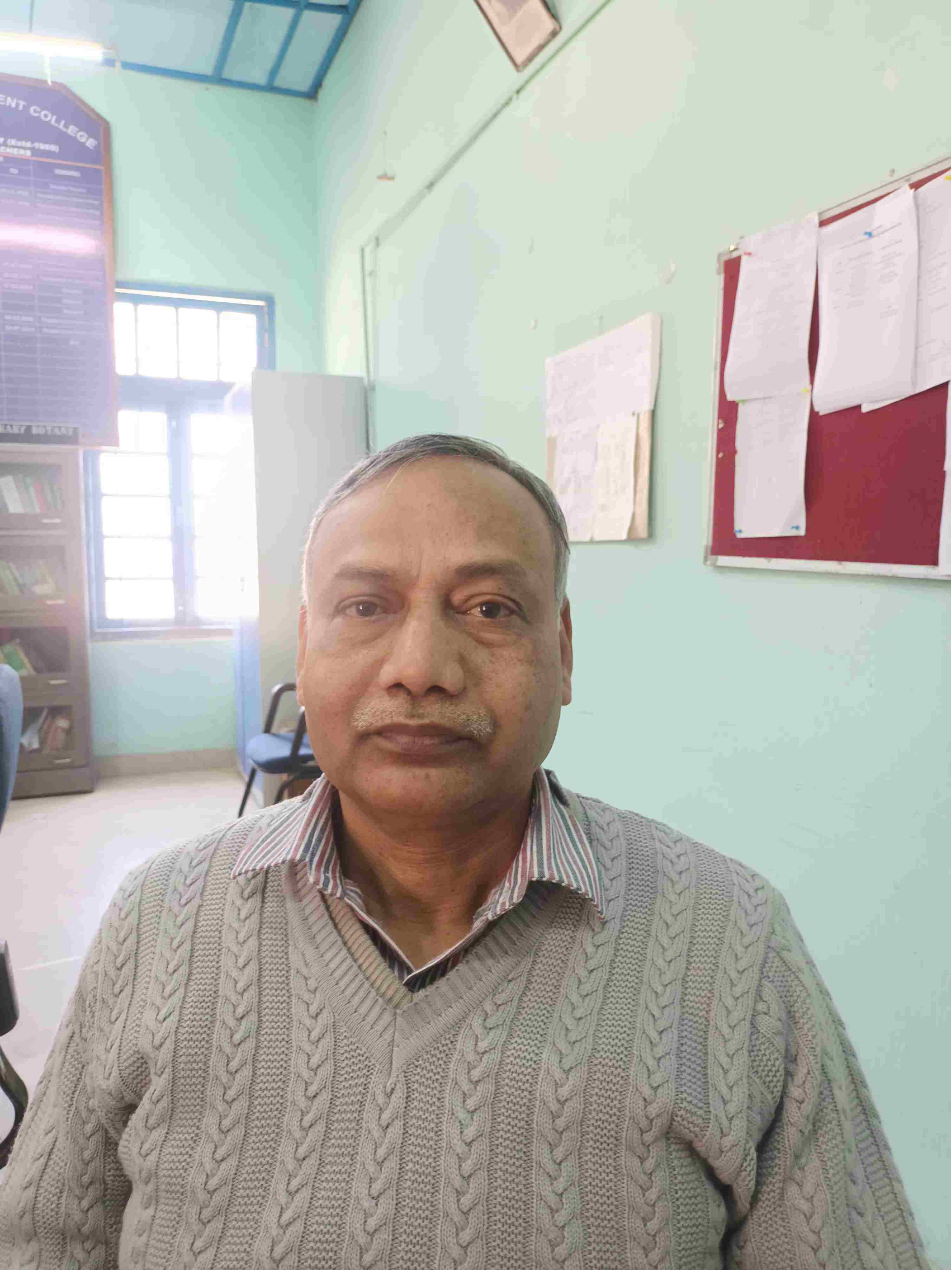

The students of the 2024-2025 FYUG, Botany Core students of Haflong Govt. College present the first issue of the Annual E-magazine, “Nature Plant”. This publication is an amalgamation of the student activities during 2024-2025.
The faculty members of this department have always provided opportunities to students to participate in extracurricular activities. We feel along with the academics extra-curricular activities are an integral part of college life. The students of the Department of Botany made wall magazines every year.
Student Seminars were also a regular feature in our department. So during the unprecedented times like Covid-19 we tried our best to organize events on digital platforms and encouraged our students to participate in online events organized by other colleges and organizations. In this issue of “Nature Plant” you will find the student activities during 2024-2025, all offline.
The term Nature Plant is very familiar to all associated with Botany. The dictionary meaning is ‘one of the small flowers making up a composite flower head.’ Small though they may be individually, “Nature Plant” make a beautiful flower head like the vibrant of Gloriosa superba. Every student of this 2024-2025 has been instrumental in the publication of the first issue of the E-magazine of the Department of Botany. I hope publication of the Annual E-magazines, Nature Plant, become a regular feature in future. Wishing all 2024-2025 incoming FYUG students the very best as they embark on their new journey as undergraduates.
Dr. Jamshed Ali
6thSept,2024

Faculty Members
Department of Botany

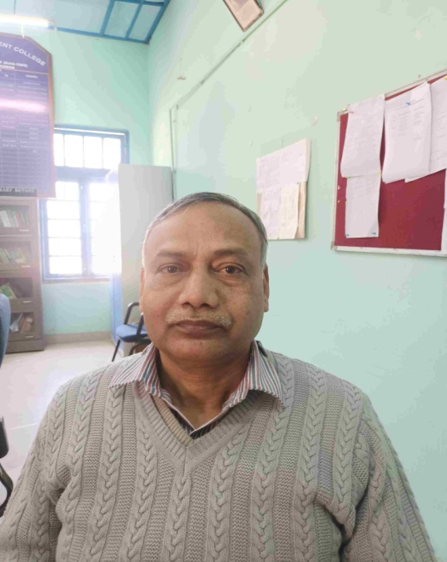

Dr. Ron Kemprai, M.SC. M.Phil. M.D Dr. Jamshed Ali, MSC. MPhil. Ph.D Dr. Rishikesh Upadhyay, MSc, MPhil, PhD
Specilisation- Genetics & Plant Breeding Specialization- Microbillogy & Pathology Specialization - Biochemistry & Physiology

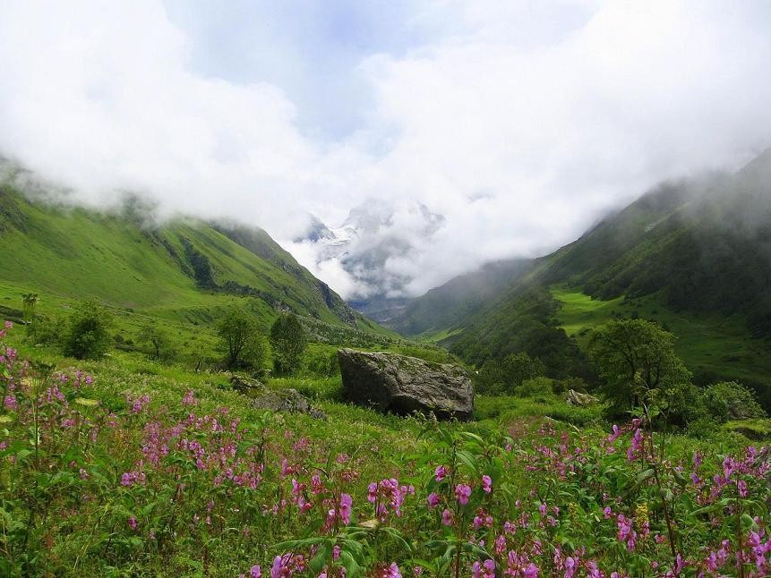
Floras of Western and Eastern Himalayas.
-Samjona Limbu

Semester: FYUG-IST
RollNo: BOT-20
Guidedby: Dr. Jamshed Ali


Introduction:
Himalayas are divided in terms of Eastern, Western and Central Himalayas. The Eastern and Eastern Himalaya share different from each other in many ways. Western Himalayas is higher than the eastern himalayas. Eastern Himalayas receive more rains than the Eastern Himalayas and are thus greener too. The Eastern Himalayas rise more abruptly from the south to north than Western Himalayas. The western Himalayas is broader from south to north than the eastern himalayas. The Eastern Himalayas is more prone to earthquakes and landslides. The temperature is much less in the Western Himalaya than the Eastern Himalaya.
The Flora of Western Himalayas:-
Western Himalayas are rich in biodiversity. It consists of a wide variety of floras. It has three types of eco-regions viz. Western Himalaya broad leaf forests.

The Western Himalayan broad leaf forests are dominated by big trees like Quercus glauca, Betulasp. Ferns, mosses, epiphytes etcare common. Alpine areas are dominated by Rhododendron sp. These shrub lands are alpine meadows also known as bugyals, where native herbaceous floral diversity is found. E.g– Delphinium, Aster, Anemone, Stellariaetc. Ephedra, Juniperus are found in the drier parts of this region. Abiesspectabilis, Rhododendron campanulatum, Pinus wallichiana, Cedrus deodara, Pinus gerardiana,Taxus wallichiana are found growing in sub-alpine conifer forests.

Flora of Eastern Himalayas:-
Eastern Himalayas is one of the floristic region as categorized by D.Chatterjee(1960). It is a home to many endemic species. This region is divided into following zones– Tropical and sub tropical zone with warm and humid conditions extending from the foot hills upto an altitude of 1850m. Temperate zone which extends from 1850m to 4000 m altitude and has oak forest.
Alpine zone:-I text ends from 4000m to 5000m altitude. The eco region has two broad forest types–evergreen and deciduous. Evergreen forests are characterized by oaks chiefly Quercus lamellosa together with Rhododendron arboreum, Lithocarpus pachyphylla, Rhododendron thomsonii etc.


Difference in flora between Western and Eastern Himalayas–
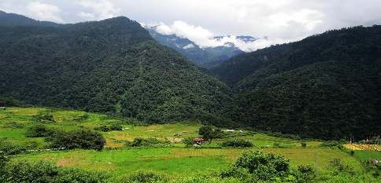
Conclusion: Flora of any place is the direct expression of the climate of the place which in turn depend on latitude in allocation, rainfall, soil etc. due to these floral characteristics of Eastern and Western Himalaya differ.

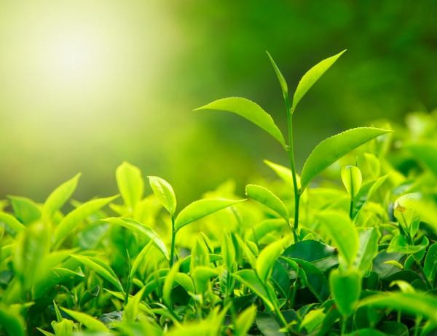
Tea Processing
-Nikita Hojai

Semester: FYUG-IST
RollNo: BOT-20
Guidedby: Dr. Ron Kemprai

Introduction
Camellia sinensisis a species of evergreen shrubs or small trees in the flowering plant family Theaceae, whose leaves and leaf buds are used to produce tea. It is an evergreen shrub native to China and East Asia. After water, it is the most widely consumed drink in the world. It has a stimulating effect in humans primarily due to its caffeine content. It was first recorded in China in 59BC, though probably originated earlier. Although each type of tea has a different taste, smell, and visual appearance, tea processing for all tea types consists of a very similar set of methods with only minor variations. The categories of tea are distinguished by the processing they undergo. In its most general form, tea processing involves different manners and degrees of oxidation of the leaves, stopping the oxidation, forming the tea and drying it. The innate flavor of the dried tea leaves is determined by the type of cultivar of the tea bush, the quality of the plucked tea leaves, and the manner and quality of the production processing the yunder go. After processing, a tea may be blended with other teas or mixed with flavor ants to alter the flavor of the fina sinensis.

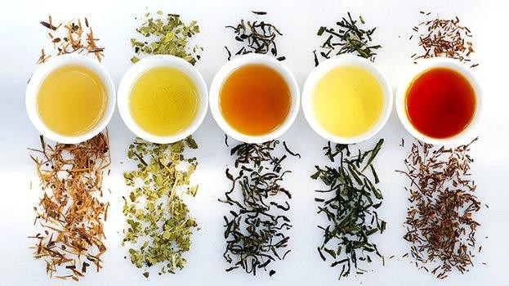
Scientific Classification:
Kingdom: Plantae
Order: Ericales
Family: Theaceae
Genus: Camellia
Species: C.sinensis
Binomial Nomenclature:
Camellia sinensis

History of the aromatic beverage:
Tea plants originated in the region encompassing today’s south west China, Tibet, North
Myanmar and Northeast India and was consumed as a medicinal drink.
It was popularized as a re-creational drink by Chinese Tang Dynasty with further spread to East Asian countries from where it travelled to England by the Portuguese priests and merchants. Later the Englishmen started huge scale cultivation of tea in India.

Tea Processing:
The green tea leaves are mainly plucked by women, who are wearing a basket or line over their shoulder in which they are collecting the leaves. The rule„ two leaves and the bud “is strictly followed. The plucked leaves are examined on the collection point and weighed before the actual processing starts.
The actual processing of any kind of tea comprises of these major processes:
- WITHERING:
Here, the thick and still immalle able leaf is rid of approximately 30% of its humidity. There
Are two methods:
  - The natural withering where the leaves are spread out on laths which are covered with jute, wire or nylon nets. The withering time takes, depeding on the weather and humidity content of the leaves, between 14-18 hours.
  - The modern withering in large troughs of a length of 25-30 metres which are covered with wire grids and are ventilated with large ventilators. These canal so be used to warm the leaves, should it be necessary, to reduce the withering time to 8-12hours.

- STEAMING:
Leaves plucked to be processed tea are delivered to crude tea factory right away, where they are steamed by heat immediately. The purpose of steaming is to inactivate the enzyme by heat. Without steaming, enzyme in leaves change the components inside, one of which is oxide of catechins caused by polyphenol oxidaze.
- DRYING:
On the high point of the fermentation, the leaves are transported through so-called tiered dryers on metal convey or belts. The tea is dried for approximately 20 minutes with hot air of 80-90°C which makes the cell fluid stick to the leaves and gives it its dark brown to black colour. The final humidity of the leaves is between 5-6%.

Different kind of tea:
The different type of tea that we have undergoes different processing techniques:
- GREEN TEA
  - Green tea in Japan is obtained by steaming the fresh tea leaves then rolling followed by drying.
  - In China the same green tea is processed by panning the fresh leaves then rolling and further drying.
- OOLONG TEA:
It is obtained by withering the fresh leaves followed by parching, rolling and finally drying.
- WHITE TEA:
It doesn’t undergo many steps it’s just withering and drying.
- BLACK TEA:
The processing includes withering of the fresh leaves followed by rolling, fermentation and drying.
- YELLOW TEA:
It undergoes spanning of the fresh leaves then it is rolled then slightly dried this is followed by post heating fermentation and dried again.
- DARK TEA:
Panning of the fresh leaves followed by rolling, drying, post heating fermentation and finally drying.

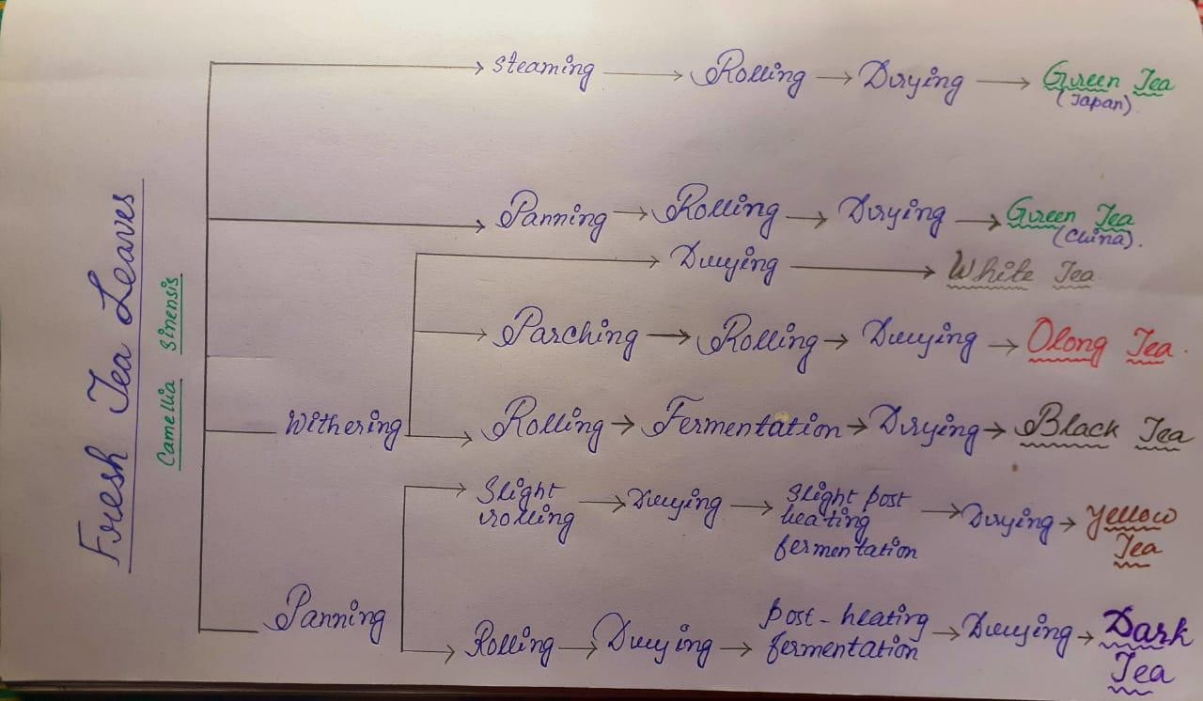

Health benefits:
Studies have shown it helps with cancer, heart disease, diabetes, encourage weight loss, lowers cholesterols and brings out mental alertness.

Conclusion:
India ranks the second largest and produces 9,00,000 metric tones of tea per annum. Assam being the largest producer in India.
The tea industries offer direct employment to 1.2 million people and support more than 3 million dependents of tea garden workers, with women accounting for 50% of the employment. The beverage has contributed significantly to socioeconomic development in far flung remote and interior areas.

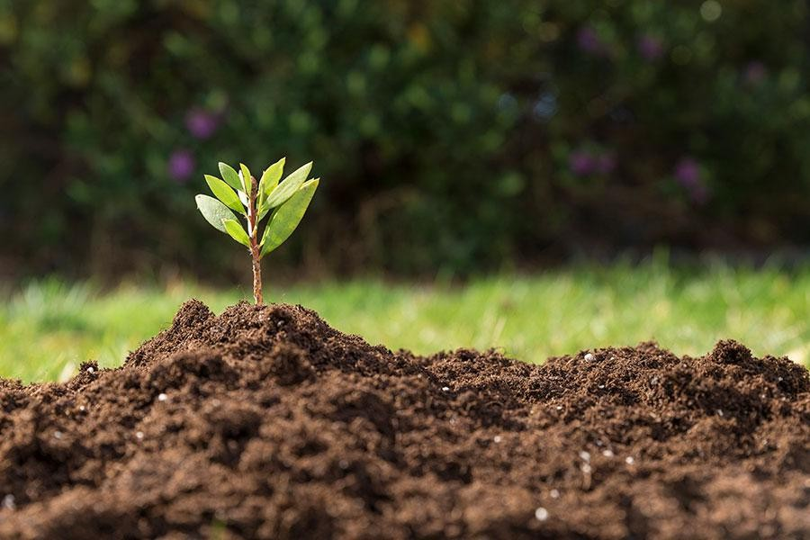
Phytoremediation
- Neha Naiding

Semester : VI
RollNo : BOT-13
Guided by: Dr. Ron Kemprai

What is phyto-remidiation?
From Greek word, Phyto=Plants and Latin word, Remedium=restore balance. Phyto-remediation is a Bioremediation process that uses various types of plants
To remove, transfer, stabilize, and/ or destroy contaminants in the soil, air and ground water.
Bioremediation-◇Microbial remediation
- Phyto-remediation
  - zoo-remediation
- Discovery: Ilya Raskin of Rutgers University coined the term Phyto remediation in 1991 agrant proposal to super fund program of the US Environmental Protection Agency.

DIFFERENTTYPESOFPHYTOREMEDIATION:
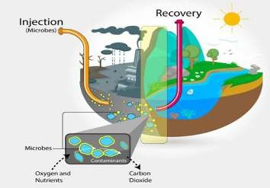
- PHYTO EXTRACTION
- PHYTO STABILIZATION
- PHYTO TRANSFORMATION
- PHYTO STIMULATION
- PHYTO VOLATILIZATION
- RHIZO FILTRATION
- PHYTO EXTRACTION:-
In this sub process plants remove dangerous elements from soil or water mostly heavy metals that have a high density and may be toxic to organisms even at relatively low concentration.
- PHYTO STABILIZATION:-
Phyto stabilization involves the reduction of the mobility of heavy metals in soil.
- PHYTOTRANSFORMATION:-
Also known as phyto degradation, it is the break down of contaminants taken up
Plants by metabolic processes within the plant.

  - PHYTOSTIMULATION:-
Phyto stimulation also referred to as rhizo-degradation, is the breakdown of organic
contaminants in the soil via enhanced microbial activity in the plant root zone or
rhizosphere.
  - PHYTOVOLATILIZATION:-
Phyto volatilization refers to the uptake and transpiration of contaminants present in the
water taken up by the plant and releases it to the atmosphere.
  - RHIZOFILTRATION:-
Rhizo-filtration is the adsorption on to plant roots or absorption into plant roots of
contaminants that are in solution surrounding the root zone (rhizosphere).
Example of some phytoremediatory plants:-
Bacopa monnieri, Eichhornia crassipes, Pteris vittata, Salix sp.
Helianthus annuus, Ricinus communis, Brassica juncea, Populus deltoides.
Advantages:
- “nature” method, more aesthetically pleasing.
- The cost of phyto-remediation is lower than that of traditional processes both in situ and ex situ.
- The plants can be easily monitored.
- The possibility of recovery and re-use of valuable metals.
- Minim all and disturbances.
- Reduces potential for transport of contaminants by wind, reduce soil erosion.
- Hypera ccumulators of contaminants mean much smaller volume of toxic waste.
- Multiple contaminants can be removed with the same plant.
Limitations
- Phytoremediation is limited to the surface area and depth occupied by the roots.
- Slow growth and low biomass require a long term commitment.
- With plant based systems of remediation. It is not possible to completely prevent
The leaching of contaminants in to the ground water.
Conclusion:
Phyto remediation is an emerging technology that employs the use of higher plants
For the cleanup of contaminated environments.
Dominant Flora:

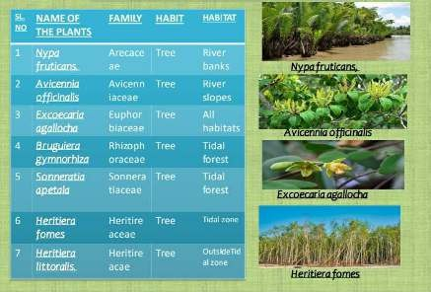
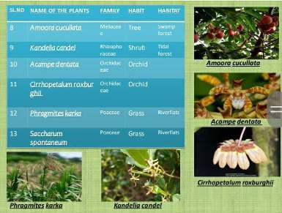

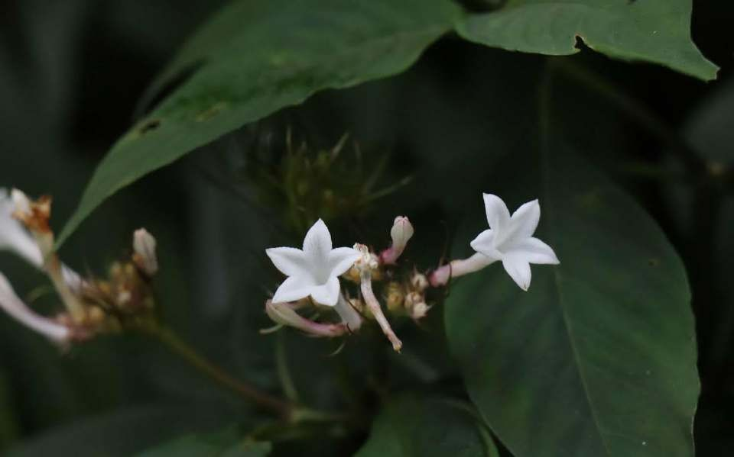
Endemic species of Indian Flora
- Nirmali Kemprai

Semester: Ist
RollNo:BOT-15
Guidedby:Dr.Ron Kemprai

Taxa with a restricted distribution are called Endemic taxa and endemism is defined as the
Phenomenon of restriction of species or genera to a smaller area due to their specific ecological niches and edaphic gradients. India is relatively rich in Endemic species, because of its unique geographical position, like the lofty mountain barriers in North and the dry Tibetan plateau and also the ocean in the south. Endemism in India Theories related to endemism in India:
- “THEFLORAOFINDIAISAMIXTUREOFSURRONDINGCOUNTRIESLIKEMALAYASIA,
ORIENTAL AFRICA,TIBET, CHINA & JAPAN” hooker (1904) champion & tever (1938).
- “INDIAHAS A FLORA OF ITS OWN” Chatterjee (1960)
Endemictaxaofangiospermsarelocatedin25hotspotofIndia.Theseare:
- Southern Western Ghats(1286sp)
- Eastern & Western Himalaya 1808) sp(
- Others are: Assam ,Khasihills, Deccan Peninsula, Nilgiri hills. Asteraceae:
Range from tropical to high alpines. Anaphalisaristata, Anaphalislawii from western ghats. Vernonia ramaswammi from western ghats& Vernonia membranacea from silent valley.

Asclepidicaeae: Restricted in Himalayanduars & Deccan Peninsula.
Tylophora cappridifolia, Tylophora rotundifolia from western ghats. Taxo carpus
Beddomei from western ghats.
Acanthaceae: Restricted to Deccan Peninsula.
Andrographis viscosula, Andrographis rothii from western ghats.
Barleria pillosa, Barleria longifolia from western ghats.
Balsaminaceae:
Confined to eastern western Himalaya & western ghat. Impatien sverticiillata,
Impatien scordata.
Rosaceae:
Alpine region of Himalayas & few in western ghat.
Rosa brunonii &Rosa acicularis in western ghats.
Primulaceae:
148 species are endemic to estern Himalayas. Primula stuartii, Primula obliqua.
Rubiaceae:
Confined to estern western Himalaya & western ghat Hedyotis obovatum, Hedyotis swertioides in western ghat.
Ophiorriza hirsutula, Ophiorriza grandiflora.
Papillionaceae:
Dalbergia beddomei, Tephrosia sp e.t.c in western ghat. Millettia pachycarpa From Assam, Astragalus himalayanus in western Himalaya. Crotolaria longipies, Crotolaria globosa etc.

Conclusion:
The endemic species are important to maintain a balance in the ecosystem. A balanced ecosystem purifies the environment and provides us with fresh air to breathe. When an endemic plant species becomes extinct, it takes with it around 10 to 30 endemic animal species. They are focus on the conservation of biodiversity.

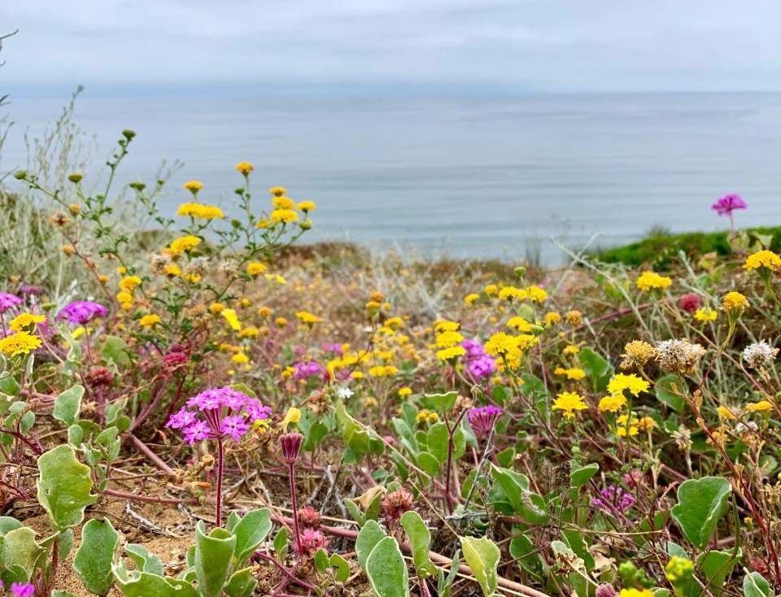
Endemism
- Felica Lalhrietzing

Semester:Ist
RollNo:BOT-11
Guidedby:Dr. Ron Kemprai

Introduction:
Endemism is a phenomenon of confinement of spices genera or other groups in a particular area beyond which their existence is not found.
According to area of distribution the species may be continental endemic, endemic to a country, provincial regional or local endemics.
Endemism means the confinement of a particular species, genus, or groups of plants and animals to a particular area. Taxa occurring only a single restricted geographical area is known as endemics. Endemism normally applied only where there is a considerable restriction in the area of distribution. Endemism is the ecological state of being unique to a defined geographical location, such as Island, Nation, Country or other defined zone, or habitat type. Organisms that are indigenous to a place are not endemic to it if they are also found else where. The extreme opposite of endemism is called cosmopolitan distribution.

Endemic species:
The concept of Endemism was first given by Candolle. When a species is found only a particular geographical region because of its isolation, soil and climate conditions, it is said to be endemic.
TYPE OF ENDEMISM:
Relic Endemism: The plant species survi vorofonce widely distributed form called Relic Endemism.
Ex: Ginkgo biloba in China
Neo Endemism: The plant species originated recently which have had note nough time to occupying a large area called NeoEndemism.
A lot of work is going on Neo endemics. On the basis of cyto taxonomic studies
Favager and Contandrio poulis (1961 ) differentiated 3 types of neo endemics.
- Schizo endemics: Derived from or having given rise to a more wide spread taxon of same
Chromosome number.
- Patro endemics: Restricted diploids which have given rise to wide spread polyploids.
©Apo endemics: Restricted polyploids which have arisen from wide spread diploids.
Ex: Shorea robusta
Pseudo Endemism: The plant species originated as a mutated form distributed widely and may loose their mutated form called Pseu Endemism.
Progressive endemics- When a species has evolved in a certain area from which it can not or has not spread.
Progressive endemics which have evolved recently include
Various species of Hieracium of mountain districts in India. EX: Lasiococca, and Treutlera in Eastern
Himalayas; Decaleps is in Decan; Primula minutissima in western Himalayas.
Conservative endemics-When a formerly much-more wide spread species has with drawn to a particular area where competition is less fierce; where the habitat is other wise more favourable. Taxodium distichum in southeast of North America are conservative endemics.


Fatty acids and it’s importance
- Babitha Naiding

Semester:II
RollNo:BOT-04
Guided by: Dr. Rishikesh uphadyay

Introduction
During the recent decades, awareness towards the role of fatty acids in human health and disease prevention has been unremittingly increasing among people. Fish, fishoils, some vegetable oils, nuts etc. are rich sources of essential fatty acids. Many studies have positively correlated essential fatty acids with reduction of cardiovascular morbidity and mortality, cancer prevention etc.
A part from dietary sources, fatty acids have a wide range of commercial applications as well. They are used not only used in the production of numerous food products but also in soaps, detergents, and cosmetics. Soaps are the sodium and potassium salts of fatty acids. Some skin-care products contain fatty acids, which can help maintain healthy skin appearance and function.

Importance of fatty acids:
Dietary sources
Fish is an excellent dietary source of omega-3. People can also meet there commended omega-3 in take by Eating plant-based foods, including omega-3-rich vegetables, nuts, and seeds.
There are three main types of omega-3 fatty acid, which are called ALA, DHA, and EPA.
Plant sources, such as nuts and seeds, are rich in ALA, while fish, seaweed, and algae can provide DHA and EPA fatty acids.
- Fish oil
Mackerel, Salmon, Sardines, Trout etc are excellent sources of fatty acids.
Fish oils are processed mainly from pelagic fatty-fish species. In modern human diet, they are the major sources of Long-Chain Poly unsaturated Fatty Acids (LCPUFAs), especially omega-3 fatty acids. They are used as healthy additives and ingredients in many value-added food products or health-food capsules, often sold at high prices. Fish oils, produced by a cooking process, are pressed and purified in several steps. The proteins are denatured and removed by pressing. Thereafter, the oil is separated. They different their fatty acid composition depending on the species of origin and seasonal variations. Fish oils are greatly unsaturated and in need of stabilization with antioxidants to protect against oxidation and deterioration of the product.
It is a good source of EPA and DHA.
- Coconut
Coconut oil is a rich source of saturated fatty acids, and short- and medium-chain fatty acids account for 70% of these fatty acids. It has a low content of unsaturated fatty acids with an egligible content of both n:6 and n:3 poly unsaturated fatty acids and a low n:6/ n:3 ratio(<4). The highly resistant nature of
Coconut oil to oxidative rancidity is at tribute to its high concentration of saturated fat and low unsaturated fatty acids. This quality makes it suitable for storage without deterioration.
Coconut oil is a rich source of Lauric acid, Myristic acid, Palmitic acid, Caprylic acid, Oleic acid, Linoleic acid and many more.
- Soybean
Soy bean oil is considered a low saturated acid oil and is high in poly unsaturated acid content.
Soybean oil (unhydrogenated) is the largest commercial source of omega-3(7–8%) acids in the US diet and a rich source of omega-6 essential fatty acids (55%). Typically, soybean oil has an iodine value of 130–132. Saturated acids (palmitic and stearic) form total about15%,mono unsaturated (omega-9) forms about 24%, with the remainder consisting of the a fore mentioned omega-3 and omega-6acids
Conclusion
Fatty acids are important biocompounds which take part in complex metabolic pathways, thus having major biological roles.
Fatty acid derivatives, such as hydroxyl fatty acids, fatty alcohols, fatty acidmethyl /ethyl esters, and fatty alkaline, have a wide range of industrial applications including plastics, lubricants, and fuels. Currently, these chemicals are obtained mainly through chemical synthesis, which is complex and costly, and their availability from natural biological sources is extremely limited.

Phytogeographical regions of India
-Pinush Nunisa

Semester:II
RollNo:BOT-36
Guidedby:Dr.Ron Kemprai

Introduction:-
According to D.C hatterjee (1962), India can be divided into nine phyto-geographical regions. This region comprises north and south Kashmir, part of Punjub and Kumaon region of Uttaranchal. The region is wet in outer southern ranges and slightly dry in the inner areas.
A phyto-geographical region is defined as an area of uniform climatic conditions & having a distinctly recognizable type of vegetation.
Phytogeographical regions:-
According to D. Chatterjee (1960), Indian Dominion can be divided into eight phyto-geographical regions.
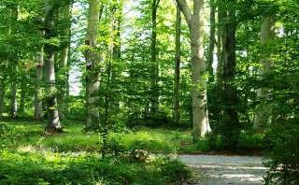
- Deccan
- Malabar
- Indus plain
- Gangetic plain
- Assam
- Eastern Himalaya
- Central Himalaya
- Western Himalaya
  - Deccan:-
    - Geographical limits-The region comprises Southern Peninsular India comprising Andhra Pradesh, Tamil Nadu, Maharashtra, Orissa
    - Dominant Flora–Shorea robusta, Phoenixa caulis, Tectona grandis etc.
  - Malabar:-
    - Geographical limits-The region extends from Gujrat, major parts of Maharastra
Karnataka and Kerala.
    - Dominant Flora– Cocu snucifera,Tectona grandis, Acacia melanoxylon etc.
  - Indus Plain:-
    - Geographical limits-The region includes Punjub, Himachal Pradesh, Rajasthan.
    - Dominant Flora:- Bombax malabricum, Tamarix articulate,Tama rixdioca etc.
  - Gangetic Plain:-
    - Geographical limits-The regions covers part of Delhi. West Bengal & part of Orissa.
  - Dominant Flora- Areca catechu, Acacia arabica, Rhizophora mucronata etc.

Assam:-
    - Geographical Limits- The region covers most of the Assam.
    - Dominant Flora- Dendro calamus, Ficus villosa,Gnetum gnemone etc.
  - Eastern Himalayas:-
    - Geographical limits-This region extends in the Himalayas from east of Nepal upto
Arunachal.
    - Phytogeographical divisions:-
- Sub mountain Zone
- Temperate Zone
- Alpine
- Sub mountain Zone– TREE-Shore arobusta, Tectona grandis, Ficus hispida.
- SHRUBS&HERBS-Bute aminor, lxora undulate etc.
Climber-Bauhinia vahlii
GRASSES-Saccharum spontaneum
- Temperate Zone–
TREES-Rhododendron arboretum, Acercamp belli, Several sp. of Dendrobium.
- AlpineZone-
TREE-Rhododendron lepidotum, R.setosum, Salix sp.
SHRUBS-Daphniphyllum himalayense.
Central Himalaya:-
    - Geographical limits- The Region comprises of Nepal.
    - Dominant Flora-
- Tropical belt Cassia fistula, Bauhinia vahlii.
B. Sub tropical belt Sachima wallichii–Castanopsis indica forest in east and Pinus roxburghii
forest in west.
C. Temperate belt Daphniphyllum sp, Magnolicamp bellii, Pinus wallichiana
D. Sub alpine belt Abies spectabilis, Betulautilis S.foliolosa.
E. Alpine belt The shrub by vegetation is usually dominant by Rhododendron bushes.

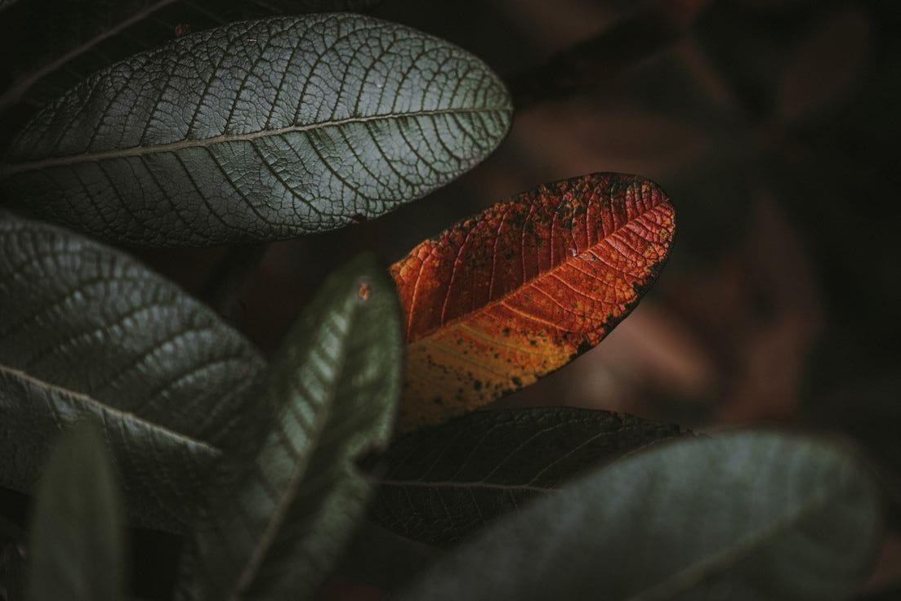
to the presentations prepared by the students during the lockdown for the students seminar is furnished below:
https://youtu.be/NxysHPEXNCo

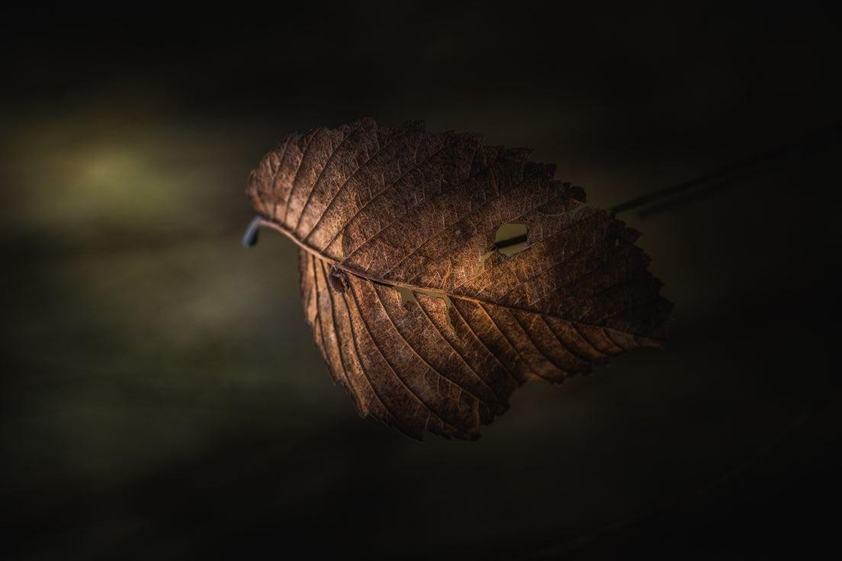
Snap shot
-Capturing the moments

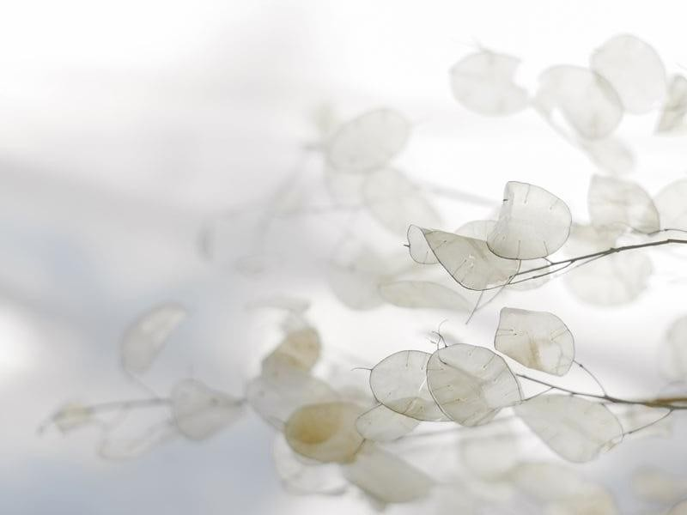
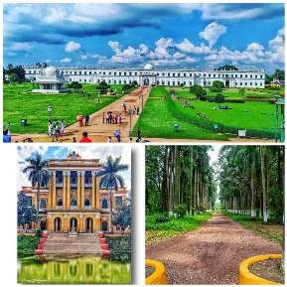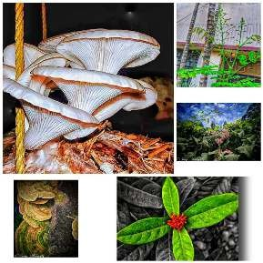
Olivia and Grecc Hmar Semester: II
RollNo:BOT-30 &36

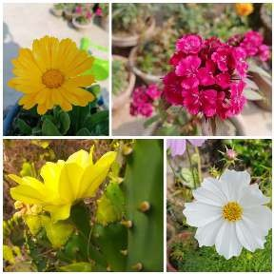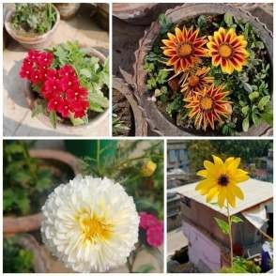
Sajal Chetri Smaily Langthasa
Roll No: BOT11 Roll No:BOT21
Semester: II

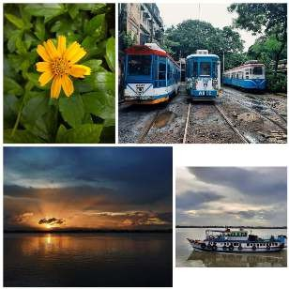

Joysringdi Longmailai Priti Daulagupu
Roll No: BOT 29 Roll No:BOT 31
Semester: II
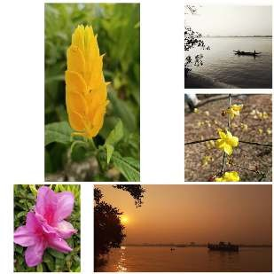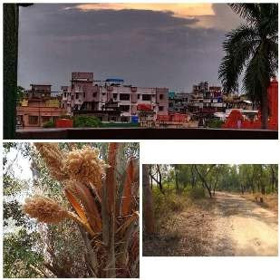
Juri Phonglo Praba Thapa
Roll No: BOT 30 Roll No: BOT 31
Semester: II

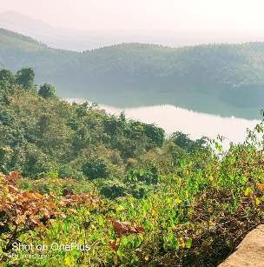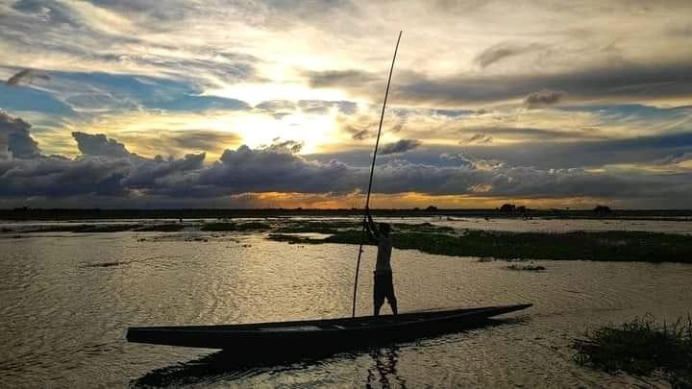

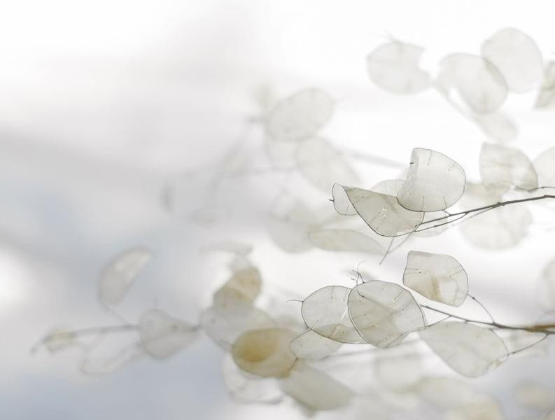
Jnalee Haflongbar Semester-VI (CBCS)
Roll number:BOT–33
Rocy Purulte
Semester–VI (CBCS)
Roll number:BOT-36



Artistic Corner

Doodle doo




Doodled by Daisy L. Nampui
Semester: VI
RollNo:BOT-41 Joshna Hojai
Semester: VI
Roll No: BOT-44

Doodle doo
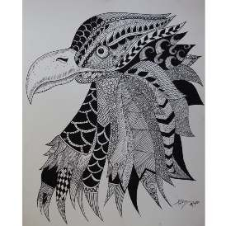
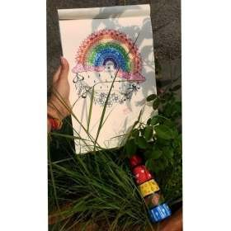

Doodled by Bebitha Kemprai
Batch: 2018-2021 Graduate, an Alumni member

Gliding with colours




Artwork by Puja Thakur
Graduate, an Alumni member


Gliding with colours

Artwork by Durba Kemprai 2020 Graduate, an Alumni member


Crafts from scraps

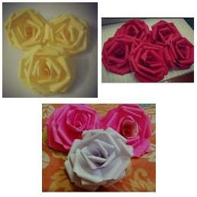
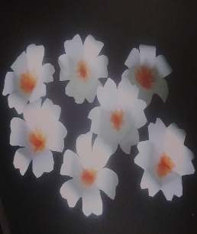

Crafted by Demasree Daulagupu
Batch: 2018-2021 Graduate, an Alumni member

Crafts from scraps




Crafted by Namrota Nabensa
Batch: 2018-2021 Graduate, an Alumni member
Crafted by Sharmila Dutta
Batch: 2015
Graduate, an Alumni member

Sugary delights
What can be a better utilization of time than learning something new? And when it comes to sweets, we all love them. How about some cakes and chocolates now?



Zenet Changsan

Graduate, an Alumni member
Batch: 2015 Kyegunglungle Jeme
Graduate, an Alumni member
Batch: 2028



Down the memory lane
-Memories to cherish for life


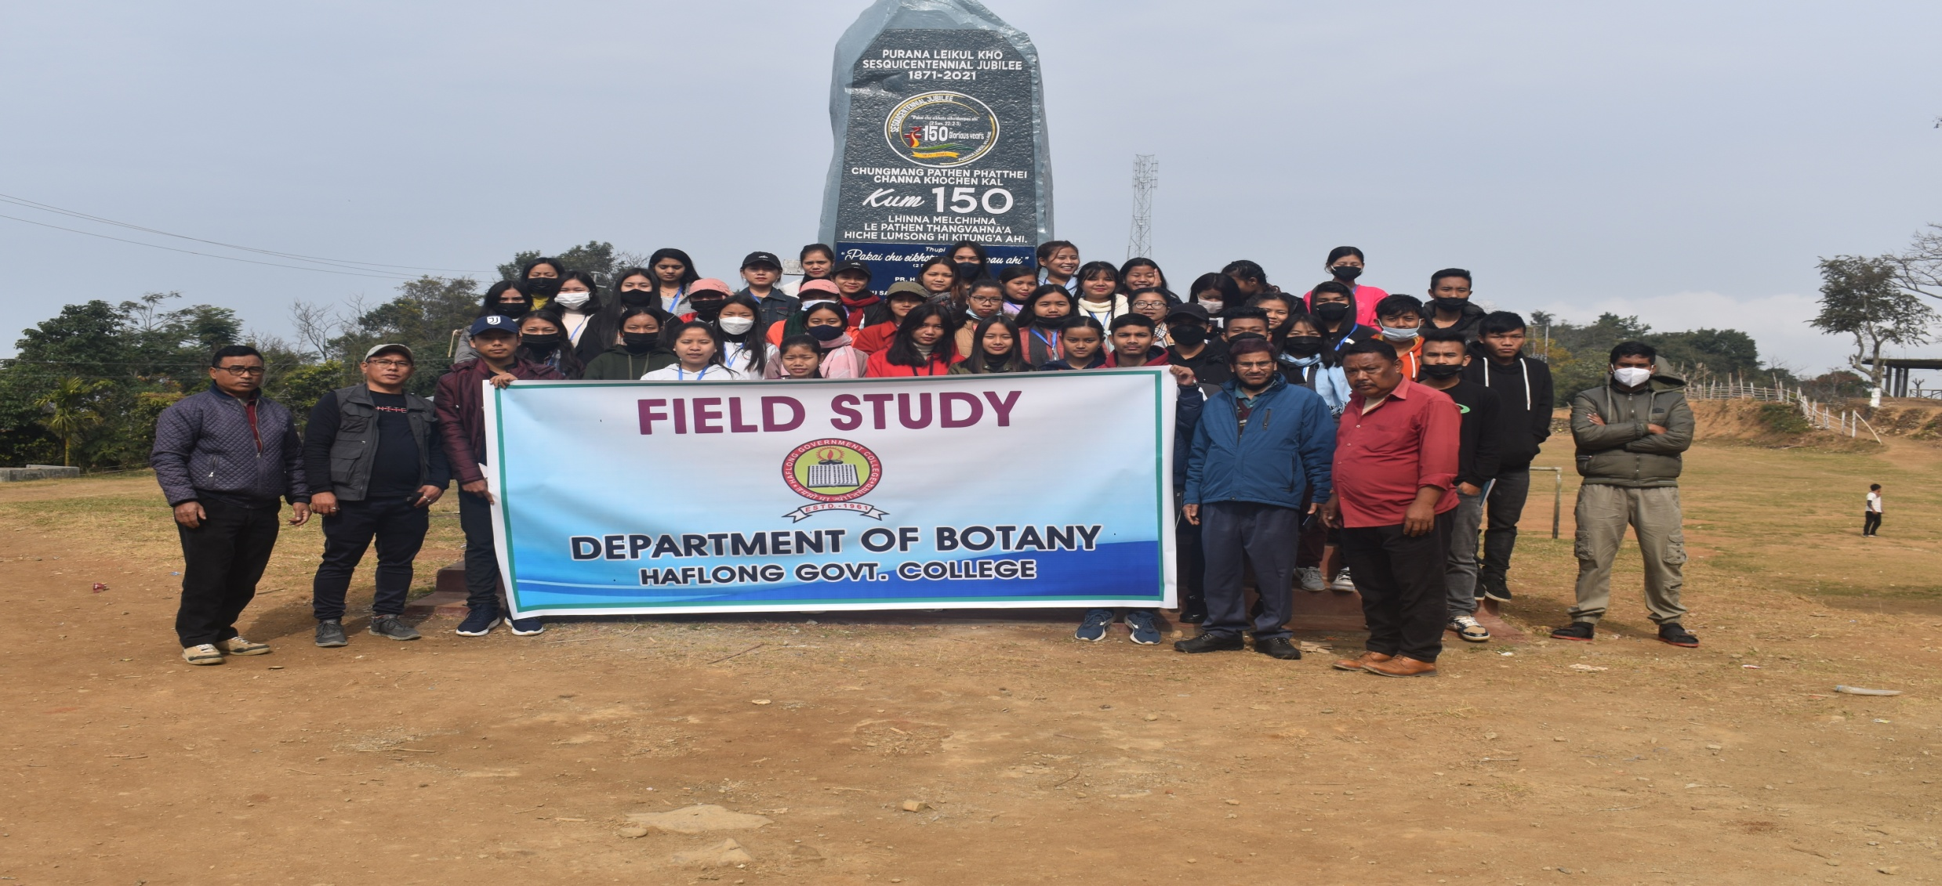
Local Field Study in Borail Ranges,
Batch 2019

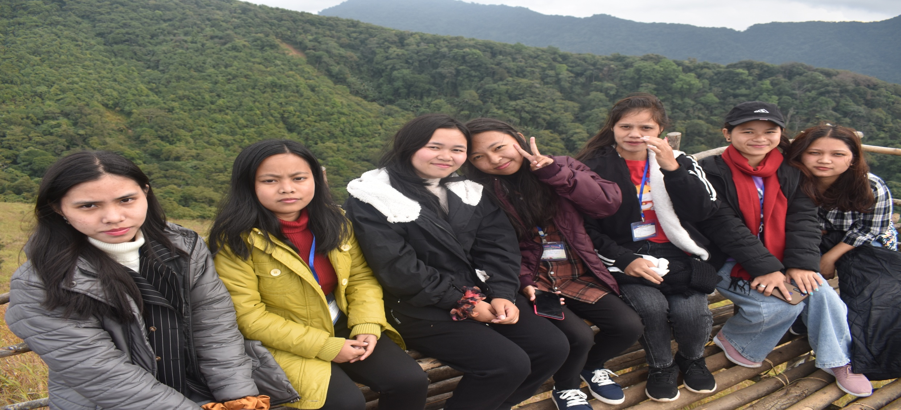
(Outgoing)Batch 2018-19
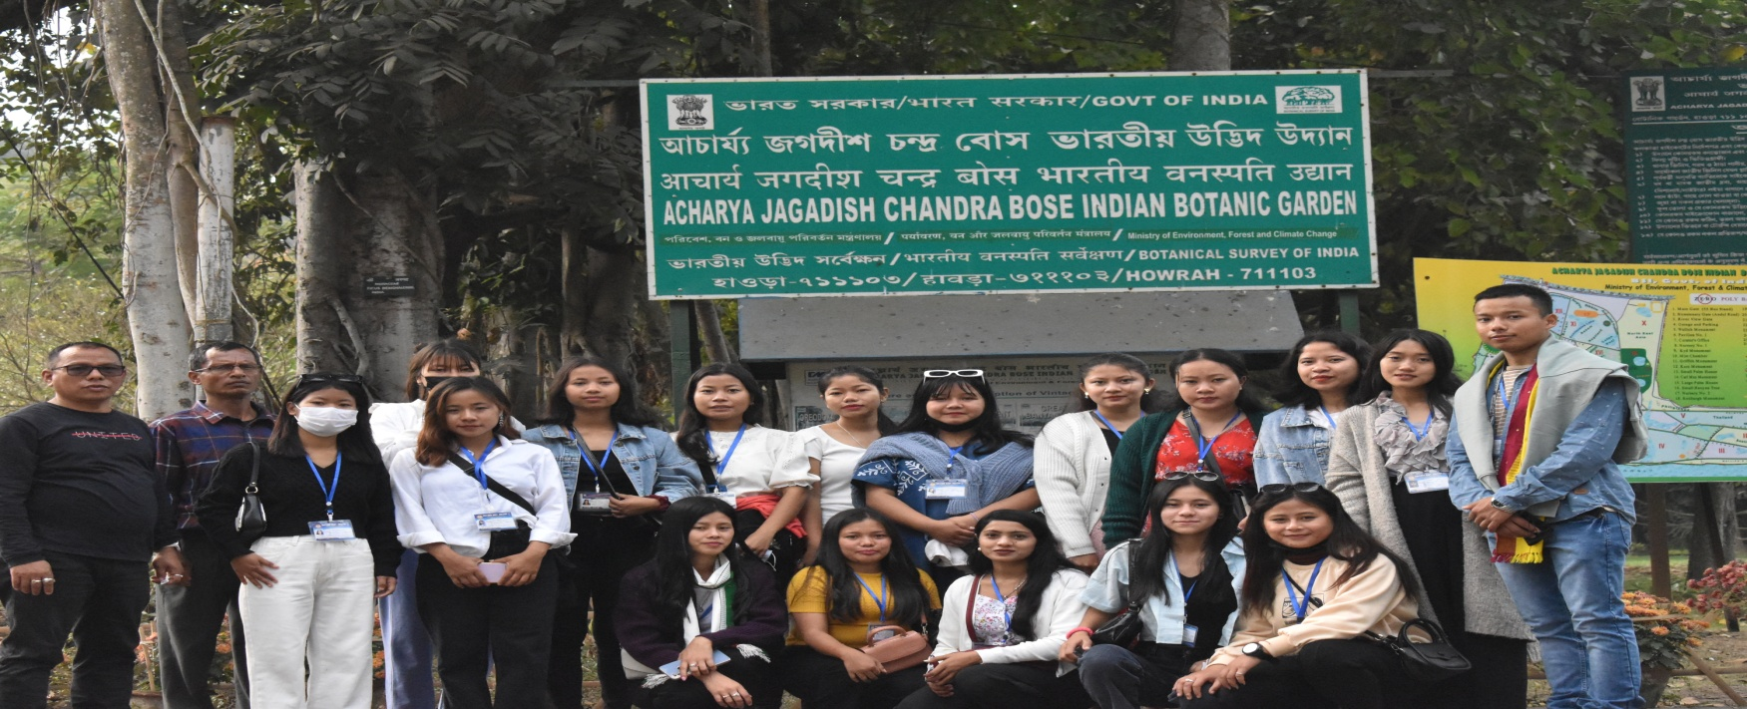
Acharya Jagadish Chandra Bose Indian Botanic Garden, Shibpur, Howrah
(Outgoing)Batch 2020-2023


Some words from our Alumni

A few words from the three Alumni members who were invited by the Department of Botany as Resource Persons for webinars in the academic session 2020-2021.


Alumni invited as Resource Person
Speaker: Dr. DIPANWITA DAS. 2011-2014 batch Assistant Professor
Dept. of Environmental Science
Amity Institute of Applied Sciences
Amity University, Kolkata & Alumnae of the Department
Date: 25th June, 2021
Digital Platform: Google Meet
Topic: A glimpse of Biodiversity with special emphasis on CBD & National Biodiversity Action Plan
You Tube Link: https: // youtu. Be /ABON23yY2s8


Alumni invited as Resource Person
Speaker: Dr.Arnav Das ,2010–2013 batch
Research fellow, Genome integrity and structural biology lab
(Dr. Paul Doetsch’s group), National institutes of Health,
National Institute for Environmental Health Sciences (NIH-NIEHS),
North Carolina, USA.
Date: 29th June, 2021
Digital Platform: Google Meet
Topic:' Innovation and Intellectual Property Rights: Opportunities and Prosperity' The Speaker holds a patent and shared his personal account of the academic journey

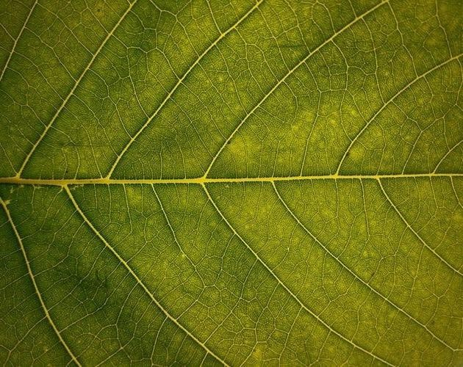
"Life is a loop” During my childhood always heard “life comes
Full circle”. During my years of transition to boring adulthood I never actually felt it. But last year I felt it for the first time when I received a message from HOD, J. Ali out giving a presentation in my own college department. It felt good inside, but it also brought me back all those interesting memories of college years. I joined the college in 2012 and spend next 3 years in the department. Today I am a full-time researcher who work every single day to wards better understanding of the puzzle of life in one of the world’s largest biomedical research organization. But looking down the memory.

She taught me things which I still follow today in my daily research life. Very early during my college days I learned that I don’t want to stay limited to my text book because my mind like to explore things beyond regular textbooks. To my younger college mates who just joined or going through your courses now I have only one suggestion “never let your marksheet define your capabilities and listen to your instincts”. I choose my career as a bench scientist and not as a professor because I still like to explore things by myself.

In my spare time I do a lot of different things including gardening and again
I learned it in Haflong Govt. college.
I wish all my younger college mates and colleagues are at journey a head in the sea of life. Don’t expect it to be smooth but again as Franklin D. Roosevelt said, “A smooth sea never made a skilled sailor”.

-Arnar Kar
Research fellow, Genome integrity and structural biology lab (Dr.PaulDoetsch’s group), National institutes of Health, National Institute for Environmental Health Sciences (NIH-NIEHS), North Carolina, USA.


It was a fascinating time to start my journey in plant science. All faculties were very kind and created a friendly environment to learn and love this subject. It was a great moment to receive the invitation from my alma mater to give a talk on Innovation and Intellectual Property Rights: Opportunities and Prosperity. I interacted with the faculty members and students from UG SEMVI Botany Hons. I was happy to share my research journey with the students. I convey my warm wishes to the SEM I-VI out going batch of Botany Hons. Students for a grand success of their E-magazine (Vol).

Thanks and regards,

Dr. Ron Kemprai
Assistant Professor,
Department of Botany,



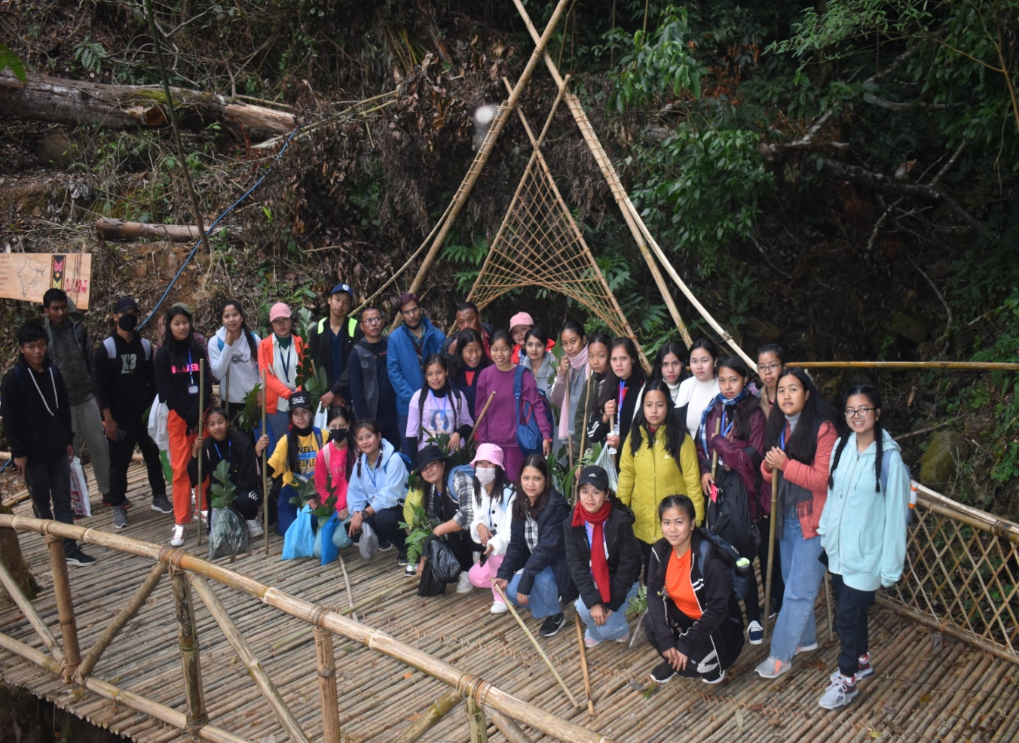

(Outgoing)Batch2018-2022

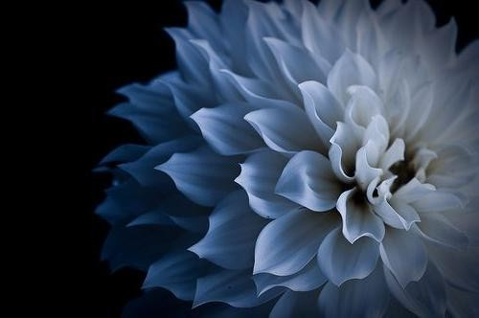

Thank you

The Editorial Team gives thanks to every one for sending in their entries.

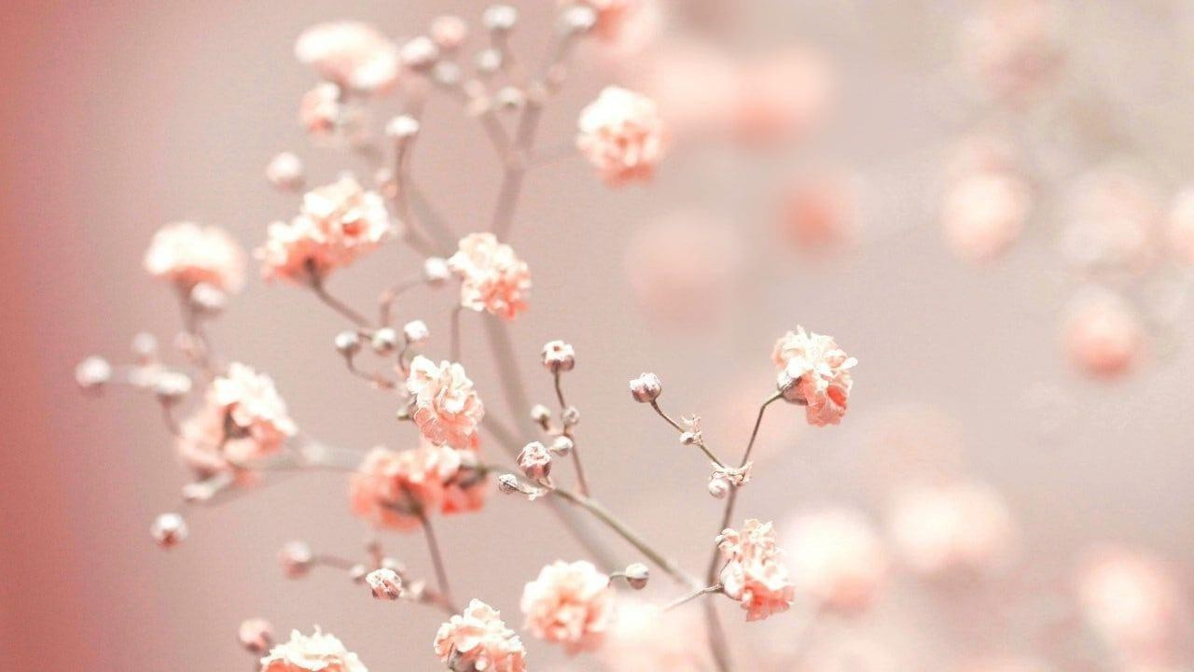
Contact Details:
Department of Botany,
Haflong Govt. College, Haflong-788819

- Email Address–
botanyhgccollege@gmail.com

- Postal Address- College Road,
Haflong,
Nature Plant, E-Magazine of the Department of Botany, Haflong Govt. College
September,2024

