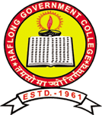


Invitation
Assam Science Technology & Environment Council (ASTEC)
in association with
The ECO Club, College Environment and Climate Cell, IQAC, Haflong Govt. College
Cordially invites you to attend the

Workshop on “Vermicomposting & Solid Waste Management”
on 17th& 18th May, 2024
in the Auditorium Hall, Haflong Govt. College.
Ms. Rupali Langthasa
MAC, Dima Hasao Autonomous Council
Will be the Chief Guest,

Dr. Sarbojit Thosan
Principal, HGC
has kindly consented to preside over the Ceremony.

Mr. Ron Kemprai

Convener

Dr. Paran Borthakur

Convener

