Inauguration of Department wall magazine on the occasion of “World Ozone Day”
20th September 2024

The wall magazine of the Department of Chemistry, Haflong Government College was inaugurated on 20th of September on the occasion of “World Ozone Day”. The students of 1st semester of DSC chemistry prepared the wall magazine with the theme “Ozone for Life” emphasizing the importance of ozone layer for the sustainable living of various life forms on earth. The wall magazine was inaugurated by the Principal of the College, Dr Sarbojit Thaosen in presence of all faculty members of Chemistry Department and faculty members of other Departments of the College. A meeting was also held at room no 102 after the inauguration of the wall magazine, which was preceded over by Dr Sanchayita Rajkhowa (Assistant Professor, Department of Chemistry). Dr Sarbojit Thaosen, Dr Sankar Neogi (HOD of Chemistry), Mrs Debbie Pakhoungte (HOD of English) and Miss Jnyanashree Darabdhara (Assistant Professor, Department of Chemistry) delivered their speech on the unfulness of the ozone layer and its depletion which adversely effects the ongoing climate change on earth. The meeting was concluded with a vote of thanks delivered by Dr Ponchami Sharma (Assistant Professor, Department of Chemistry).

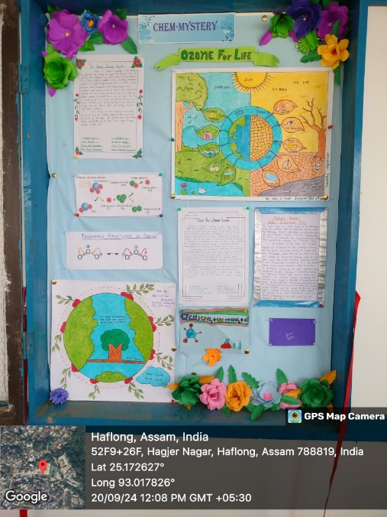
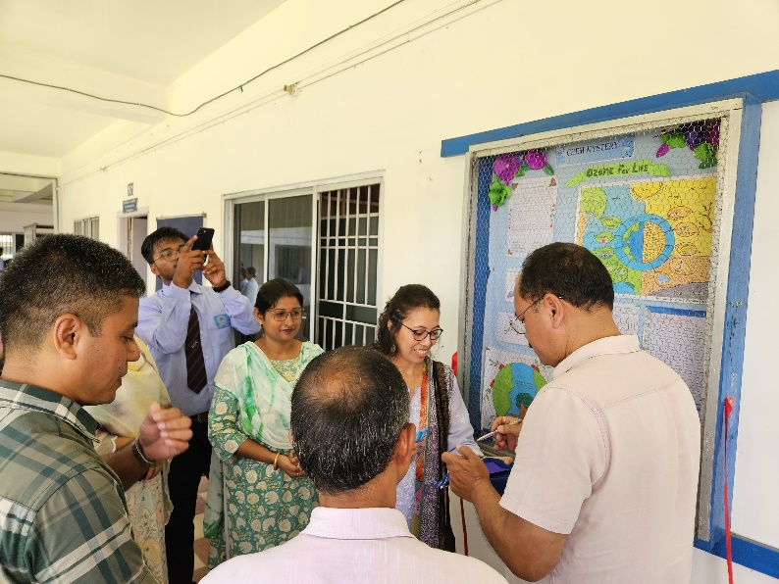

(Inauguration of the wall magazine by Dr Sarbojit Thaosen) (Wall Magazine)

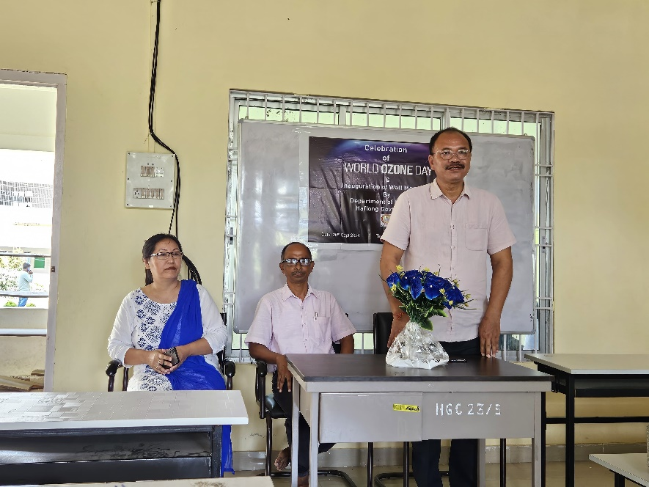
(Speech delivered by Dr Sarbojit Thaosen)

