National Science Day Celebrated on 28th of February 2024
Organised by the Department of Chemistry

National Science Day was celebrated in Haflong Government College organised by the Department of Chemistry on 28th of February, 2024 with the theme “Indigenous Technologies for Viksit Bharat”. The meeting was organised at room no C1 of commerce block and The Principal of the College along with many senior college faculty members were present at the meeting. Dr Sarbojit Thaosen (Principal of Haflong Government College), Dr Sankar Neogi (HOD of Chemistry), Mrs Debbie Pakhoungte (HOD of English) and Mr Dinesh Tiwari (Associate Professor, Department of English) delivered their speech on “Science Day” and “Importance of Science for Viksit Bharat”. The Department organised two competitions namely Poster Making competition on the topics “Sustainable Environment” and “Chemistry in Everyday Life” and an Extempore Speech competition on various topics such as “Importance of Science Day”, “Green House Effect”, “Pollution” and “Renewable Energy etc. Many students actively participated in the two competitions and won various exciting prizes along with certificates.

Photos:
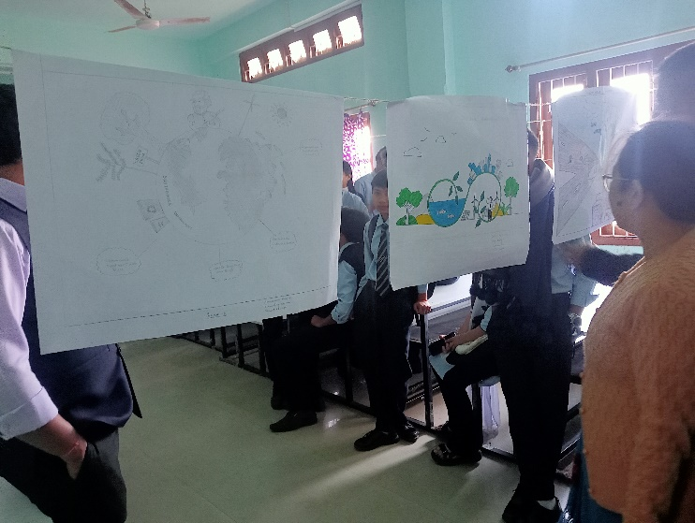
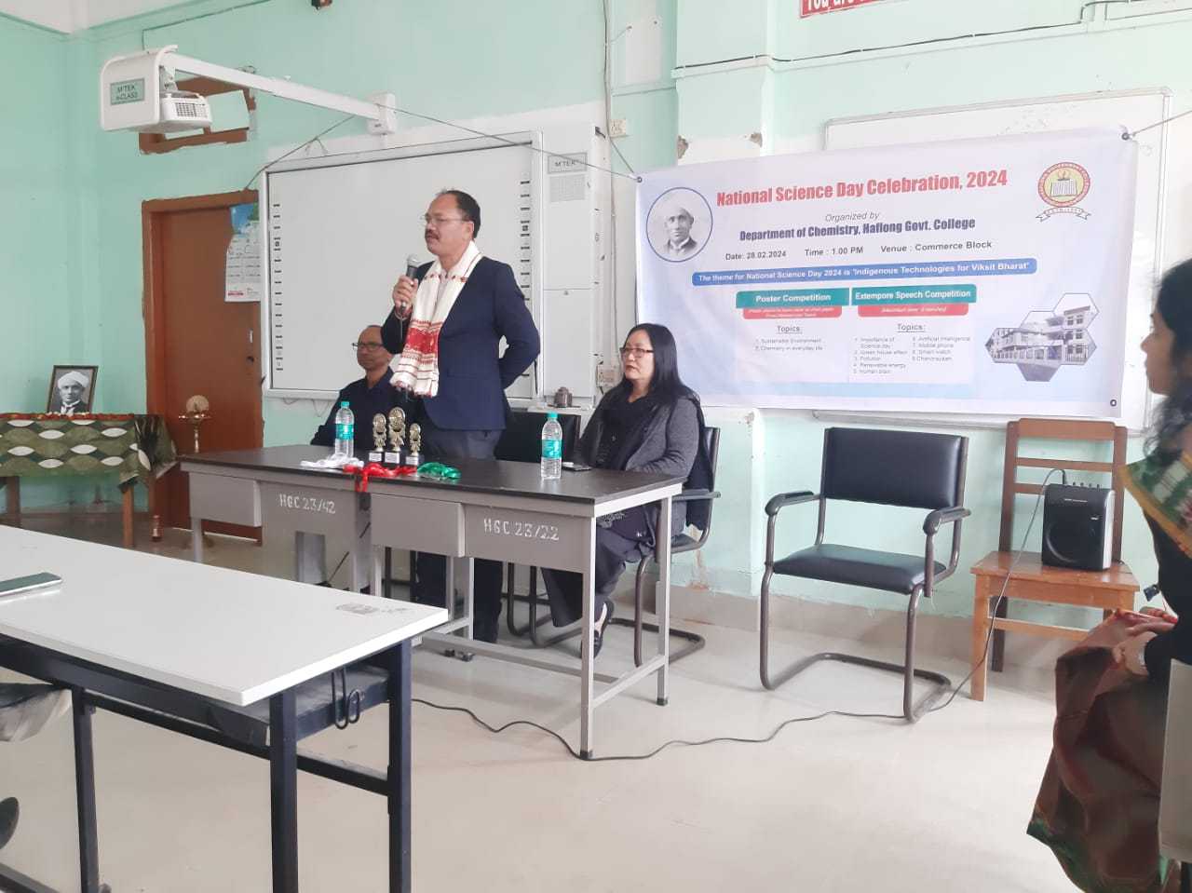

Image 1: The Principal of Haflong Government Image 2: Poster Presentation by the
during his speech students and inspection of posters
by Dr Rakhi Moni Gogoi
(HOD of Political Science)

