Department Visit by School Students

On 22nd of February 2024, a group of students accompanied by their respective school teachers from four different schools near Haflong namely “Maibang Govt. Higher Secondary School, Maibang”, “Mahur Govt. Higher Secondary School, Mahur”, Garampani Govt. High School, Umrangso” and “Govt. Girls Higher Secondary School, Haflong” visited the Department of Chemistry and the Chemistry Laboratory. The Department Faculties introduced the students about the common laboratory apparatus, their applications and the safety precautions the students need to adopt while performing practical experiments in laboratory. The Department Faculties demonstrated few experiments including “Detection of chloride ions in a given water sample” and many more.

Photos:
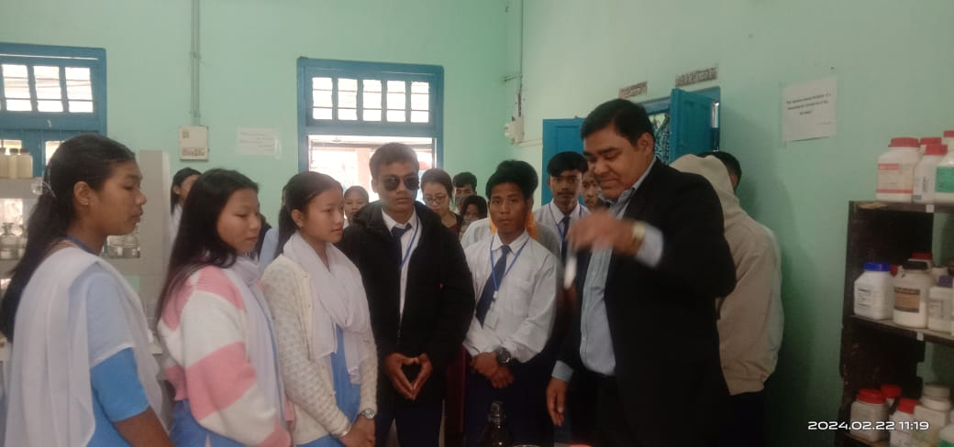
Image 1: Demonstration to the students by Dr Sushanta Kumar Roy (Assistant Professor, Department of Chemistry)
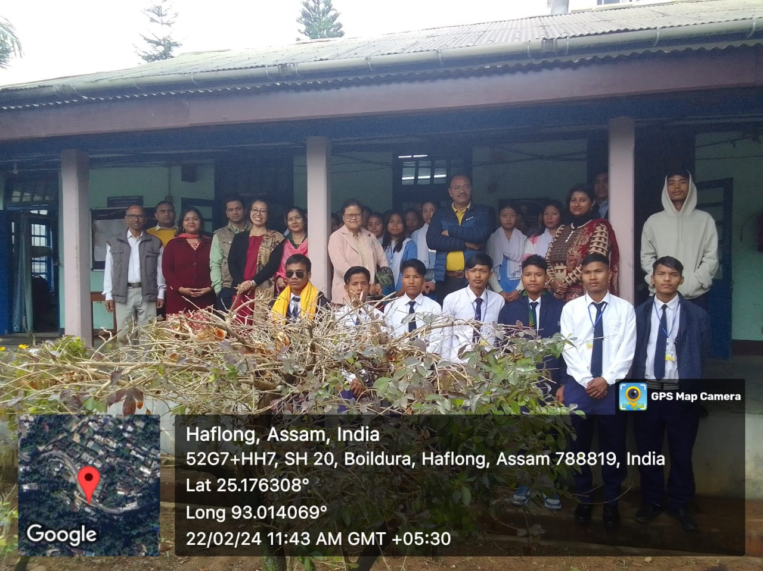
Image 2: Visiting Students and teachers from Maibang Higher Secondary School, Maibang along with the Principal and Faculty Members of Department of Chemistry Haflong Government College.

